SING LAB SESSION
9-12 24th January
Department of Pathology and Molecular Medicine

Michelle Thunders michelle.thunders@otago.ac.nz
Sara Filoche sara.filoche@otago.ac.nz

9-9.30: Introduction
9.30-10: Mitosis
10-10.45: Genetic family tree
10.45-11.20: 23 and me data exploration and discussion
11.30-12: DNA extraction and discussion

Mitosis

The term mitosis is used to describe the duplication and distribution of chromosomes, the structures that carry the genetic information. Mitosis a process of cell duplication during which one cell gives rise to two genetically identical daughter cells

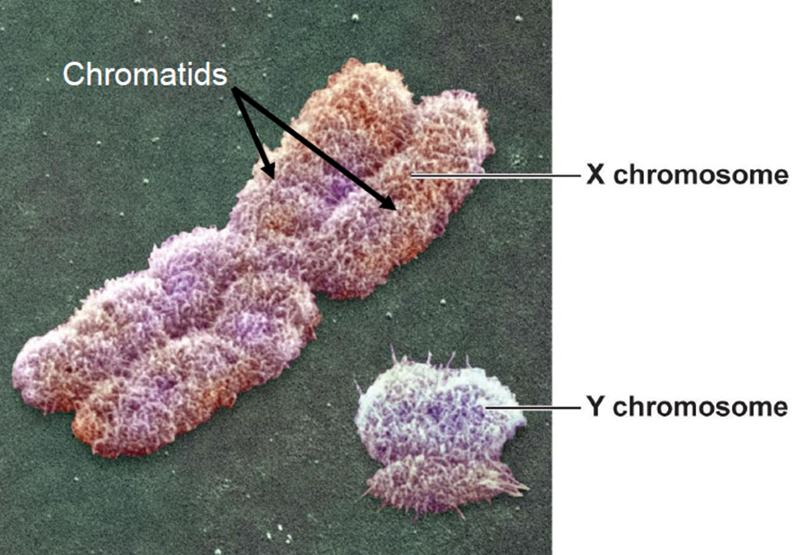

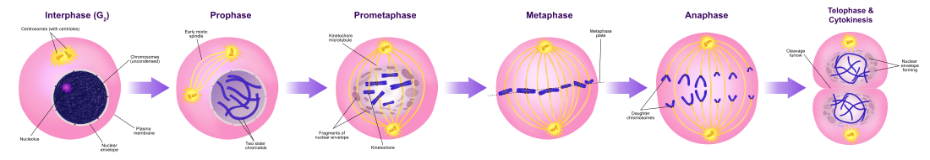

Viewing cell division and passing of genetic information.

Genetic family tree

- The genetic family history can reveal patterns of inheritance
- The genetic family history may help make or refine a diagnosis
- The genetic family history helps assess the likelihood of genetic disease in relatives
- The genetic family history can affect testing, treatment and management strategies
- The genetic family history may highlight the need for referral for specialist opinion
- Taking the genetic family history helps in building rapport with patients

Presentation and activities
Pedigree analysis of Unicorn syndrome
- Young adult onset condition, presents as a golden bone structure from the skull
- Autosomal dominant condition
- Your paternal grandfather has the condition, his wife didn’t
- Your father has the condition but his sister didn’t
- Your father married Jane
- You have three siblings, one brother, two sisters
- One of your sisters has inherited the Unicorn syndrome

Crossword (if time)

23 and Me

Data exploration
  - Data exploration from genome profile
  - Provide with genotype at a range of SNPs- online research using SNP database- what does it mean?
- Resources/time to be spent:
  - Use 23and Me website and computers and list of my snps: table below (30 mins)
  - dbSNP Home Page, http://www.ncbi.nlm.nih.gov/SNP/index.html
  - https://www.snpedia.com
- rs4244285: SNP in the CYP2C19 gene related to the antiplatelet drug clopidogrel.
- rs17646946 & rs11803731: Hair curliness.
- rs2395029: A variety of conditions (like psoriasis, abacavir hypersensitivity) plus liver damage among patients taking the antibiotic flucloxacillin.
- rs10757278: Risk for coronary artery disease and it’s consequences (like heart attacks).
- s12913832 is a SNP near the OCA2 gene that may be functionally linked to blue or brown eye color, due to a lowering of promoter activity of the OCA2 gene. Blue eye color is associated with the rs12913832(G;G) genotype.
- Rs1815739 This SNP, in the ACTN3 gene, encodes a premature stop codon in a muscle protein called alpha-actinin-3. The polymorphism alters position 577 of the alpha-actinin-3 protein. In publications the (C;C) genotype is often called RR, whereas the (T;T) genotype is often called XX.
- Rs1426654This SNP influences skin pigmentation. The allele, A111T, rs1426654(A), indicates light-skinned european ancestry

Activity based on data below: find out info about me….look up snp and interpret what my genotype means for me.

Michelle’s data: interpret
rs1815739 | 11 | 66328095 | CC
rs17646946 | 1 | 152062767 | AA
rs11803731 | 1 | 152083325 | TT
rs12913832 | 15 | 28365618 | AG
rs1426654 | 15 | 48426484 | AA
rs10757278 | 9 | 22124477 | AA
rs4244285 | 10 | 96541616 | GG
rs2395029 | 6 | 31431780 | TT

DNA extraction from strawberries
- 