Mitosis in the root tips of garlic

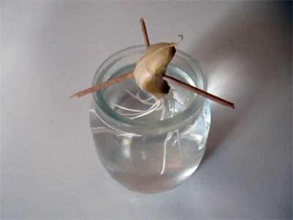

Introduction
Mitosis is a process of cell replication necessary for the growth of the organism and for the substitution of "aged" cells. Upon conclusion of this process, from the original cell two cells are derived, each of which possesses the same genetic material. Above all during the growth of organisms, the cells must multiply and to do this they undergo a series of events called the cell cycle. The cell cycle has two important stages: interphase and mitosis (Figure 1). During interphase, the cell grows in size, doubling its DNA and preparing itself for mitosis.
Mitosis involves four phases: prophase, metaphase, anaphase and telophase

Figure 1. Overview of mitosis
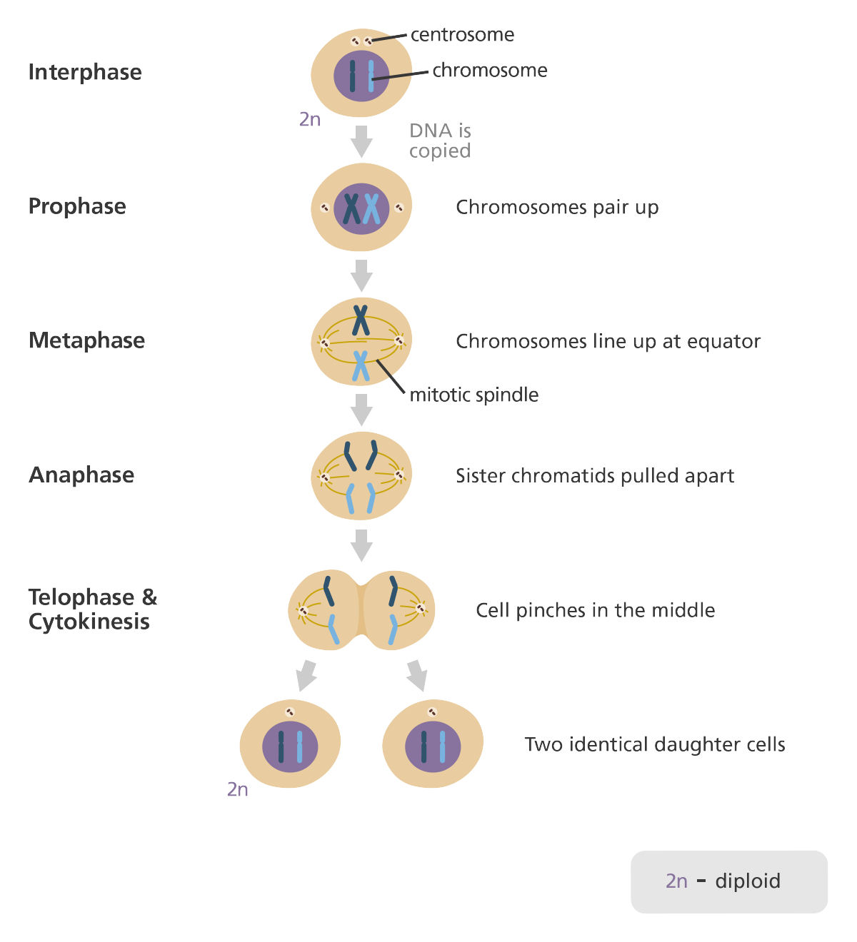

In the superior plants, mitosis occurs above all in the so-called meristem tissues. These growth tissues are found principally in the roots, in the shoots and in the cambium.

Aim
The aim of this experience is to observe and possibly photograph the process of cell multiplication called mitosis. In order to do this, we will use apical meristems of a garlic root, where the growth is greatest and therefore the number of duplicating cells is relatively high.

Materials and methods
In order to clearly observe the different phases of mitosis, the root tissues must be well fragmented, otherwise each cell will remain attached to the others obstructing all observations. To separate the tissues into small fragments, we will need hydrochloric acid which can weaken and even remove the bonds between the cells. Coloration with Toluidine blue follows, a dye for microscopy that has a strong affinity for chromosomes.
Materials
- a clove of garlic
- 4 beakers for growing garlic and rinsing off water
- 10% HCl
- distilled water and waterbath
- some clean microscope slides and coverslips
- pipette
- scissors
- tweezers
- razor blade
- 2 needles or pins
- paper towels
- microscope
- 0.5% Toluidine blue or another nuclear dye
Procedure
- place the garlic or onion to root in a glass jar;
- fill the jar with tap water until the root area is covered;
- after two or three days the roots should be sufficiently long;
- cut approximately 5mm off the tips of a couple of roots - choose the longest roots, where the process of mitosis should be more active;
- put them in a small beaker or glass jar with thin walls;
- place hydrochloric acid with a concentration of 1M in the beaker to a depth of about 5 mm - the purpose of the hydrochloric acid is to destroy the substances that unite the cells (usually pectin), but it does not destroy the cell walls. The hydrochloric acid also has the ability to kill the cells and halt the process of mitosis;
- put the beaker in a waterbath containing at 60°C for approximately 6-7 minutes, or at room temperature for approximately 20 minutes;
- remove the beaker from the waterbath and transfer the root tips to a microscope slide;
with a pipette and some distilled water, rinse away the acid;
- dry the root tips with a paper towel without touching them;
repeat the rinsing several times, care not to wash away the tips;
- with a blade, shorten the root tips to 2 mm in length, keep the tips and throw away the rest;
- with two needles or pins and under the stereoscopic microscope, carefully chop the tips and separate the fragments;
- the root tips should come undone easily, otherwise repeat the acid treatment;
colour the tissues with 0.5% Toluidine blue for 2 minutes;
- mount a coverslip;
- with a pipette, place a couple of drops of distilled water on one side of the coverslip and absorb the coloured water from the other so to remove the dye;
- using the microscope search for cells undergoing mitosis.

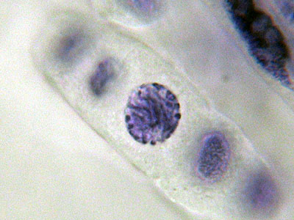 | 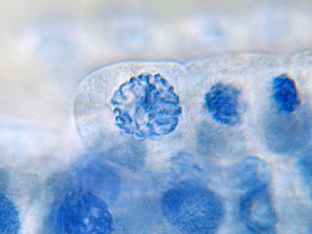
Figure 2 - Prophase: the chromosomes begin to condense, while around the nucleus spindle fibres develop which organise the separation of the chromosomes into two new nuclei. The spindle fibres are fixed to a central zone of the chromosomes  called a centromere. | Figure 3 - Prophase (as in Figure 2).
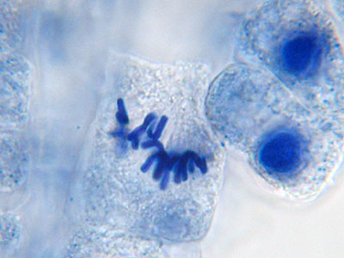 | 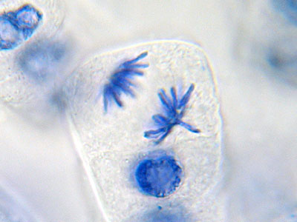
Figure 4 - Metaphase: the chromosomes line  up along the equatorial plane of the cell. | Figure 5 - Anaphase: the chromosome pairs divide and the two groups migrate to opposite poles of the cell.

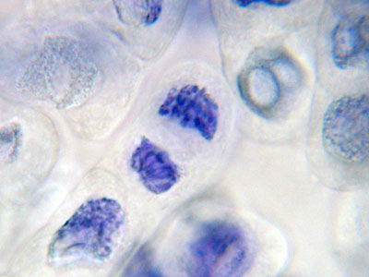
Figure 6 - Telophase: around each group of chromosomes a nuclear membrane forms, the chromosomes disperse and can no longer be distinguished. The spindle fibres dissolve. In the
equatorial zone of the cell a new cell wall forms and the two cells separate. At the end, they can no longer be distinguished from the other cells in interphase that surround them.

