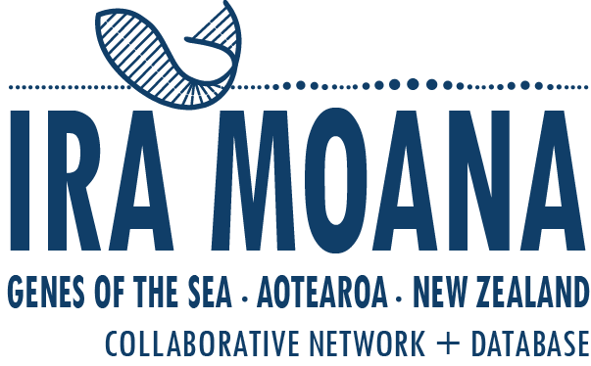

Ira Moana Early Career Workshop 27-31 May 2019, Massey University Auckland
We invite applications to participate in the ‘Ira Moana Early Career Workshop’ and to become part of the Ira Moana Network!
The ‘Ira Moana – Genes of the Sea – Network and Database’ is a collaborative, MBIE funded initiative aiming to deliver a searchable database for genetic and genomic data of New Zealand’s biodiversity. The database links genetic sequences with sample information – such as location, habitat, and date of sampling events – creating opportunities for data re-use, data synthesis, and to inform our future research directions.
The Workshop is designed to develop base skills and solidify the networks of early career scientists (from any discipline), preparing them for this new data resource. New Zealand early career scientists (including postgraduate students and those up to 8 years post-PhD) with an interest in using or exploring genetic data in a spatially explicit context, with relevance to local communities, measuring of biodiversity values, spatial conservation planning, and science communication and education (and ideas of their own), should apply!
Attendees will be 1) introduced to the Ira Moana project and the relevance of genetic and genomic biodiversity data to New Zealanders (Mon), 2) instructed in spatial analysis methods in R (Tues, Wed), and 3) trained in the principles of spatial conservation planning using the software Marxan (Thurs). There will be the opportunity for attendees to brainstorm and initiate collaborative research activities using the Ira Moana data resource (break times, evenings, and Friday morning).
The number of workshop participants will be capped at 25 persons. The Workshop will be FREE, and for successful applicants from outside of Auckland, all accommodation (Mon-Thurs) and travel to/from the Workshop will be paid for by the Ira Moana Project. Interested applicants should outline (in no more than 1 page): their research interests (or applied interests) in exploring the Ira Moana database, and any relevant experience or expertise. Applications should be sent to Dr. Libby Liggins, L.Liggins@massey.ac.nz by 5pm Tuesday, April 9.
Attendees should have some experience in using the R programming environment. For more information about the Ira Moana project, see these FAQs.
Demonstrators/Mentors:
Dr. Libby Liggins, Massey University Auckland – Libby co-ordinates the Ira Moana Project and collaborates in several international research consortia interested in making data, knowledge, and scientific expertise more accessible. Her research is interested in the generation and changing nature of biogeographic and demographic patterns in the ocean. She specialises in using genetic and genomic data, in combination with ecological data and modelling approaches.
Dr. Eric. A Treml, Deakin University, Australia – Eric is a teaching/research academic in marine science. His research expertise is in the spatial ecology of marine systems, including quantitative ecology, conservation and ecological modelling. His current research interests are around understanding the causes and consequences of population connectivity, the implications for species and genetic diversity, and assisting in local-to-global conservation planning.
Dr. Maria Beger, Leeds University, United Kingdom – Maria is a quantitative marine ecologist and conservation scientist experienced in working with NGOs and government agencies across many countries. Her research integrates field data, spatial models and decision science to find conservation solutions that link theory and practice.
Our Workshop is run with the support of Genomics For Aotearoa New Zealand (GFANZ). GFANZ is a team of individuals and organisations with an interest in the improvement of peoples’ lives through the generation and sharing of knowledge. GFANZ collective expertise includes genomics science, entrepreneurship, data science, open source technology, citizen science, open science, and science policy.

