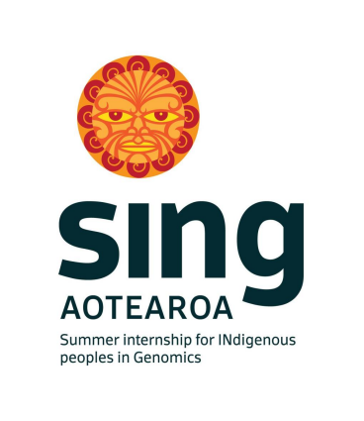
SING Webinar Wānanga
Aotearoa New Zealand (Online)
27 o Hune (June) - 1 o Hūrae (July) 2022

SING Aotearoa 2022 Webinar Wānanga Report
The Summer Internship for INdigenous Genomics is a key capacity building initiative funded by Genomics Aotearoa. The SING Aotearoa programme is designed to develop an understanding of genomics alongside some of the best researchers in New Zealand. We are grateful for researchers who make space to give their time to share their knowledge and experience. The SING Aotearoa workshop is a week-long internship, modelled on an existing SING-USA programme (http://conferences.igb.illinois.edu/sing/home).
The first day of the webinar revolved around the whakataukī “He kuaka mārangaranga, kotahi te manu e tau ki te tāhuna, tau atu, tau atu, tau atu”. This whakataukī, coined by Tūmatahina (Elder, H. 2020) speaks about the importance of relationships within a group, mentorship and leadership.
Each session highlighted different aspects of the whakataukī. To bring everyone together. The opening speakers for the wānanga were Associate Professor Phillip Wilcox and Dr Kimiora Henare. The second and third sessions focussed on tikanga and the work of leaders in the genetic and genomic spaces. The second session was Te Aroha Ki Te Tika (a love for what is right) opened by Associate Professor Sandy Morrison. Associate Professor Maui Hudson then presented on tikanga frameworks for genomics with tāngata and with taonga species before discussing Local Context Labels. The final sessions for the day was based on re-positioning genomics in a Māori space. Associate Professor Phillip Wilcox discussed Māori concepts of inheritance and Māori engagement with genomic sciences, and described the growth in Māori-led/co-led projects in genomic sciences within Aotearoa New Zealand.
The second day followed the concept of the whakataukī “E koekoe te tū, e ketekete te kākā, e kūkū te kereru” which highlighted the need for the many different bird songs that jointly make the dawn chorus - “it takes all kinds of people” (Elder, H 2020). Session one was a workshop ‘Finding needles in haystacks: Detecting pathogenic variants in whole genome sequences’ delivered to the new SING-Aotearoa interns led by Associate Professor Phillip Wilcox, Professor Stephen Robertson and Dr David Markie from the University of Otago. The topic for the final session was ‘For Indigenous, By Indigenous’ featuring guest speakers from the SING Consortium; Dr Keolu Fox (SING USA) and Professor Nadine Caron (SING Canada). Vignettes from each speaker, filmed during SING-Aotearoa 2020, were shown to the interns and alumni to provoke discussion around Indigenous involvement at every step of the genomics pipeline and at the decision-making table.
The final day of the webinar wānanga, was based on the whakataukī “Poipoia te kākano kia puāwai”, to support the interns and alumni to thrive in whichever future pathway they choose. Inspiring korero was shared to:
- encourage interns and alumni to become agents of change;
- arm them with critical tools to empower them to advocate for their Indigenous rights; and
- aid them to strategically navigate future challenges in this crucial mahi.
The first session revolved around culturally and ethically informed study design hosted by Dr Kimiora Henare drawing on published critical reflection tools to support the interns/alumni ability to identify good research. Another vignette was shown, featuring Associate Professor Phil Wilcox discussing the current state of science infrastructure in Aotearoa New Zealand, and the need for changes in within the science system to ensure Māori are able to more effectively participate in, and benefit from, genomic sciences. The second session was a keynote presentation by Professor Alex Brown from SING Australia, Professor of Indigenous Genomics at the Telethon Kids Institute and Australian National University. His kōrero was titled ‘Towards a National Indigenous Framework’, highlighting comprehensive genomics in health platform for Indigenous of Australia. The final session for the SING2022 webinar wānanga explored the concept of treading carefully in challenging waters “Me ātahaere mā ngā ngaru, kei tōtohui te aroha o Tangaroa”. Dr Katrina Claw (SING USA), the final SING consortium speaker for the wānanga spoke about indigenous scientists being a bridge followed by a discussion about how to protect oneself as an indigenous scientist and academic in different spaces.
The wānanga concluded with a round of reflections and learnings followed by a closing karakia by Dr Kimiora Henare.
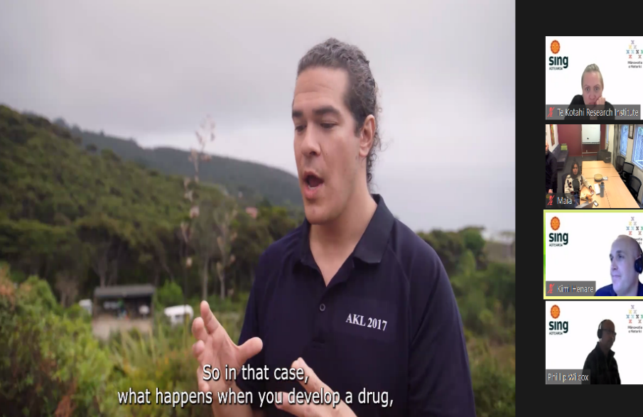
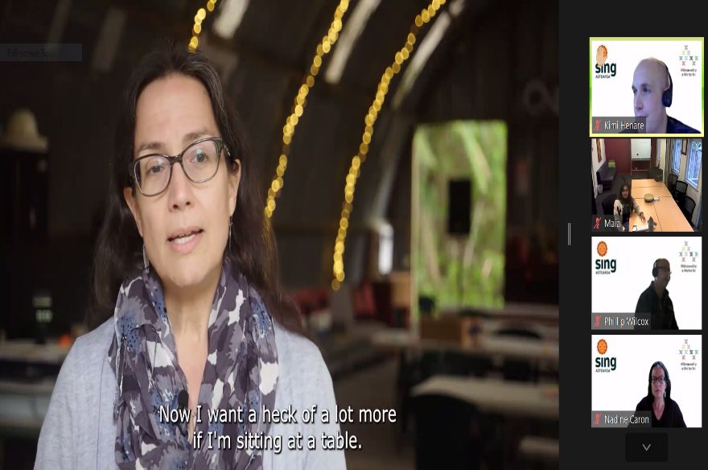
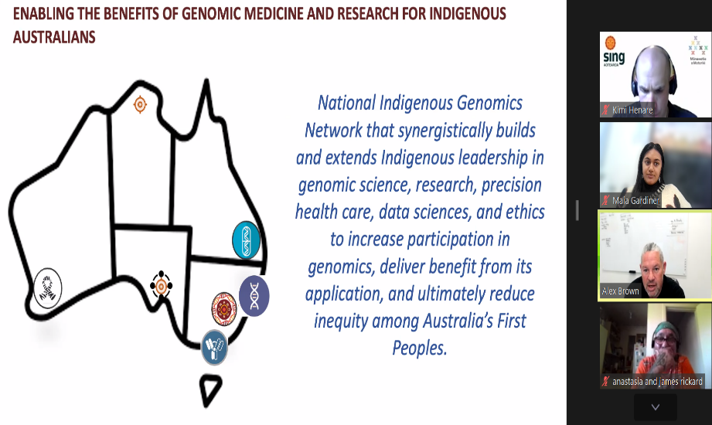
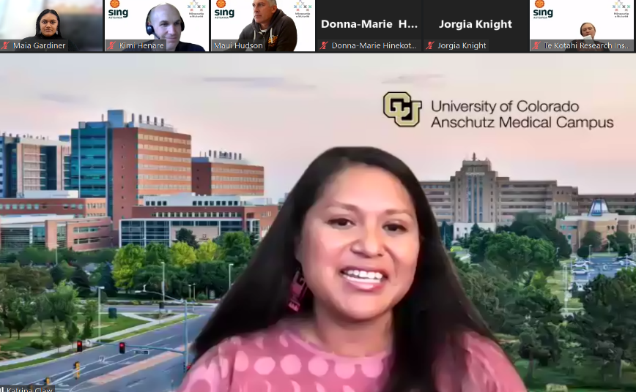
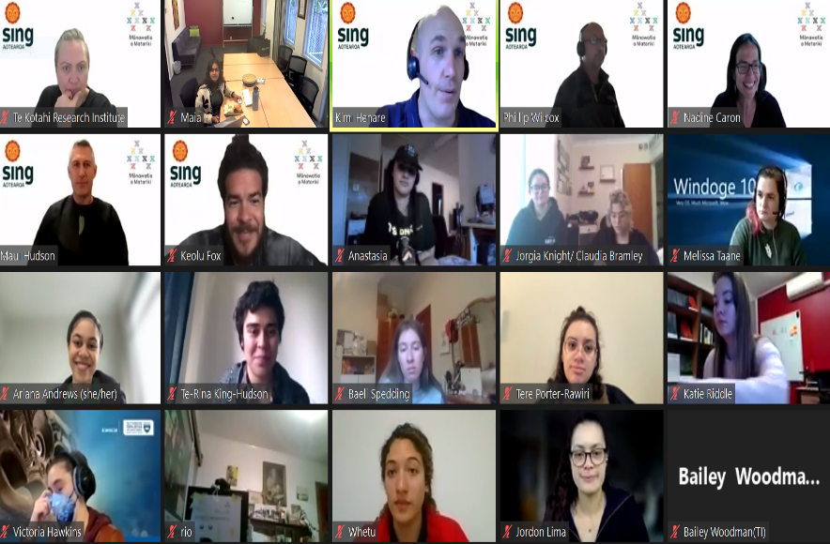
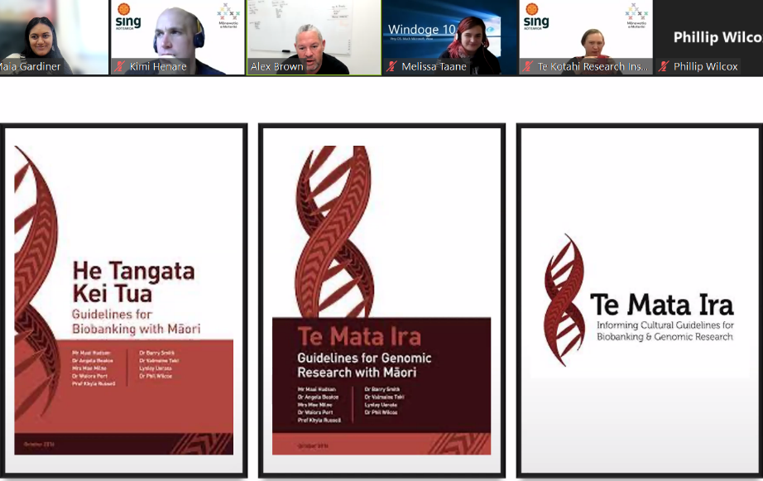

SING Aotearoa Conveners
Dr Kimiora Henare
Associate Professor Phillip Wilcox
Tuti Nikora

SING Aotearoa 2022 Webinar Matua
James Rickard

SING Aotearoa 2022 Webinar attendees
Anastasia Rickard | Jorgia Knight
Ange Hure | Katie Lee Riddle
Ariana Andrews | Maia Gardiner
Ariane Thompson | Melissa Taane
Baeli Spedding | Mitchell Head
Bailey Woodman | Natalie Kusabs
Baylee Kelepamu | Rogena Sterling
Claudia Bramley | Tere Porter-Rawiri
Donna-Marie Hinekoto Warren | Te-Rina King-Hudson
Dorothy Hayes | Tia Haira
Jordon Lima | Victoria Hawkins

CONFERENCE SPEAKERS

Associate Professor Phillip Wilcox
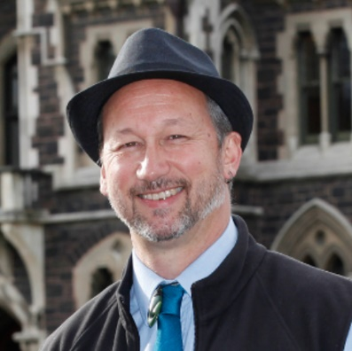
Iwi affiliations: Ngāti Rakaipaaka

He is an Associate Professor in the University of Otago’s Department of Mathematics and Statistics, with experience in applied genomics and statistical genetics. For almost 20 years he has worked in the interface of genetic sciences and Te Ao Māori, and co-leads two genomics-based projects focussing on Māori health. Dr Wilcox has also worked on genetics of plant species (particularly forest trees) and human diseases. Along with Maui Hudson and Katharina Ruckstahl, he initiated SING-Aotearoa, and is currently a member of the Health Research Council of New Zealand’s Ethics Committee which oversees institutional and regional ethics committees.

Associate Professor Maui Hudson

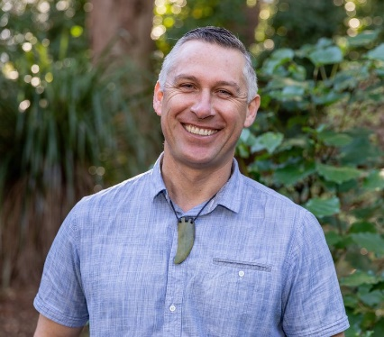
Iwi affiliations: Te Whakatohea, Nga Ruahine, Te Mahurehure.

Associate Professor Maui Hudson is Director of Te Mata Punenga o Te Kotahi | Te Kotahi Research Institute at the University of Waikato. His research is interdisciplinary in nature focusing on the application of mātauranga Māori (indigenous knowledge) to decision-making across a range of contexts from new technologies to health, the environment to innovation. Maui was part of the team that developed Guidelines for Genomic Research with Maori, and is now working on Guidelines for Genomic Research with Taonga Species. Along with Phil Wilcox and Katharina Ruckstahl, he initiated SING-Aotearoa.

Associate Professor Sandy Morrison

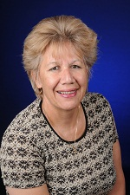
Iwi affiliations: Ngāti Whakaue, Ngāti Maniapoto; Ngāti Rārua ki teTau Ihu, Ngāti Tama ki te Waipounamu.
Her current position as the Acting Dean for the University of Waikato’s Faculty of Māori and Indigenous Studies allows her to continue to challenge the thinkers of tomorrow and concentrate on her research interests around Treaties, Adult Education and Indigenous Development. Sandy has an extensive career and holds many titles nationally and globally.

Dr David Markie
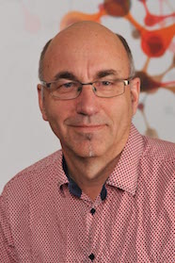
Dr David Markie is a senior lecturer at the department of pathology at Otago University. His interests is in the identification, characterisation and functional analysis of genes that contribute to the development of colorectal cancer. This includes genes responsible for rare inherited predispositions to cancer, as well as genes that are defective in the more common sporadic forms of cancer.

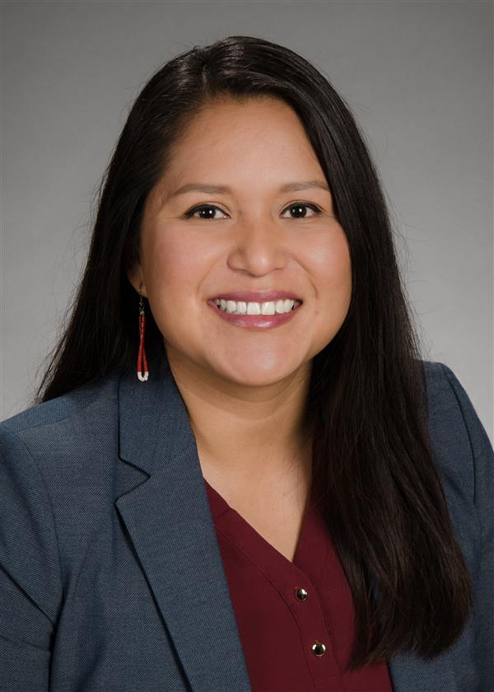
Dr Katrina Claw (SING USA)
Dine` (Navajo).
Dr Katrina Claw is an Assistant Professor in Medicine-Bioinformatics. Her research focuses broadly on personalizing medicine, using genetic information and biomarkers for tailored treatment, in relation to pharmacogenomics as well as understanding the ethical, cultural, and social implications of genomic research with populations historically under-represented in health research. Katrina was a recipient of the Genomic Innovator Award 2020 (NHGRI). Her projects include exploring the perspectives of tribal members on genetic research with tribes and developing guidelines and policies in partnership with tribes. All of her projects strive to use a community based participatory research approach and include cultural and Indigenous knowledge.

Dr Keolu Fox (SING USA)
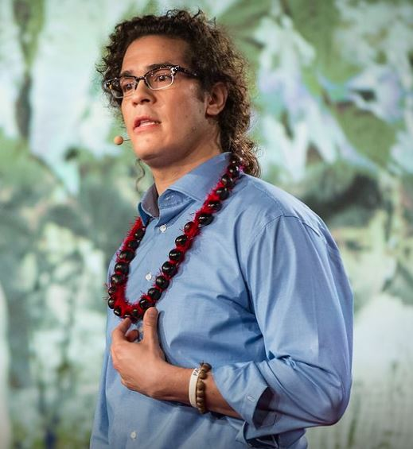
Kanaka ‘Ōiwi.

Keolu, Kānaka Maoli (Native Hawaiian), is an assistant professor at University of California, San Diego, affiliated with the Department of Anthropology, the Global Health Program, the Halıcıoğlu Data Science Institute, the Climate Action Lab, and the Indigenous Futures Lab. He holds a Ph.D. in Genome Sciences from the University of Washington, Seattle (2016). Dr Fox’s multi-disciplinary research interests include genome sequencing, genome engineering, computational biology, evolutionary genetics, paleogenetics, and Indigenizing biomedical research. His research focuses on questions of functionalizing genomics, testing theories of natural selection by editing genes and determining the functions of mutations.

Dr Kimiora Henare
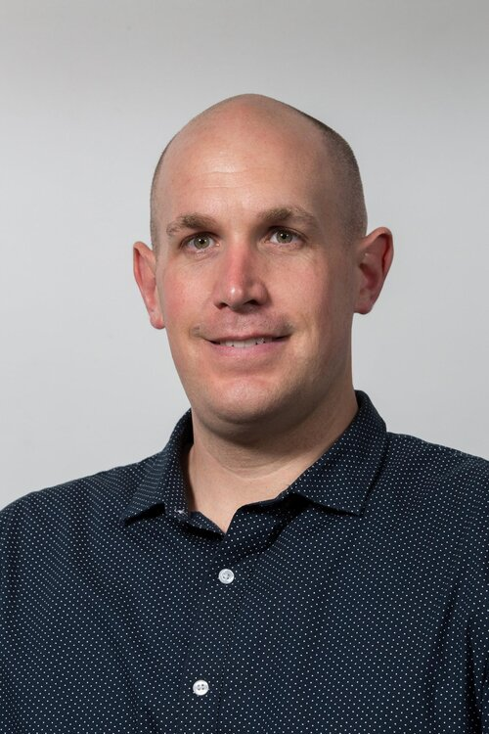
Iwi affiliations: Te Aupōuri and Te Rarawa.

Dr Kimiora Henare is an early career researcher and cancer biologist, specialising mainly on the tumour microenvironment and tumour immunology based at the University of Auckland. His primary research focuses on strategies to enhance tumour-directed immunity. Alongside his lab-based biomedical research, Kimiora worked with the NETwork! Project (www.network.ac.nz) to develop a roadmap for Māori engagement for clinical cancer genomics which has served as a scaffold for several other cancer genomics projects have since been built off that scaffold where he remains actively involved as part of a cancer genomics research team led by Professor Cristin Print. Kimiora has been involved in SING-Aotearoa since its inception in 2016
Professor Alex Brown
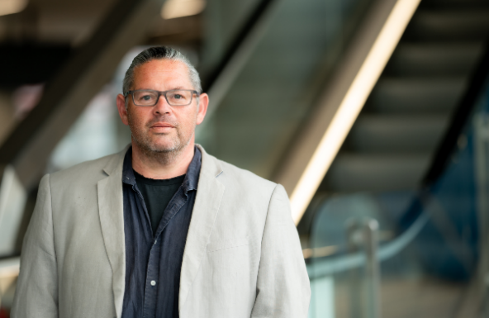
Professor Alex Brown is the Aboriginal Health Equity Theme Leader at SAHMRI, and Professor of Medicine at the University of Adelaide.
Alex is an internationally leading Aboriginal clinician/researcher who has worked his entire career in Aboriginal health in the provision of public health services, infectious diseases and chronic disease care, health care policy and research. Much of his work has been at the difficult interface of geographical isolation, complex cultural context, severe socioeconomic disadvantage, inequitable access to and receipt of care and profound health disparities, often where little or no research infrastructure previously existed. He has built a research career spanning public health, quantitative clinical epidemiology, mixed-method health service research, qualitative research, and implementation science, with an increasing focus on novel clinical trials in cardiometabolic disease within Indigenous communities.

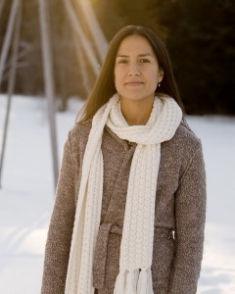
Professor Nadine Caron (SING Canada)
Anishnawbe from Sagamok First Nation.

MD, MPH, FRCSC – Associate Professor, Dept. of Surgery, Faculty of Medicine (NMP), Co-Director of Centre for Excellence in Indigenous Health. Dr Nadine Caron currently resides in Prince George, BC where she provides surgical oncology care for those that call rural and remote Canada home. Nadine is also an associate professor in the UBC Faculty of Medicine’s Department of Surgery where she teaches in the Northern Medical Program. Her work involves a variety of audiences and knowledge users including governments, provincial health authorities, national medical organizations, health research funding bodies, and several universities to achieve identified and overlapping objectives.

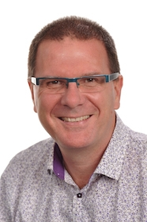
Professor Stephen Robertson
Professor Stephen Robertson is the Curekids Professor of Paediatric Genetics in the Department of Women's and Children's Health at the University of Otago. From 1999–2002 Stephen was Nuffield Medical Fellow at Oxford University, studying the genetic determinants of congenital malformations in children. His work has led to the implication of a new family of genes, the filamins, in the generation of these conditions. He remains an active clinical geneticist as well as continuing his research into congenital malformations. He heads the Clinical Genetics Group, which studies single gene disorders in children, with a particular emphasis on disorders that affect the development of the skeleton and the brain.
APPENDIX: Programme
SING 2022 Virtual Wānanga Hōtaka (Programme)
Rāhina (Monday), June 27, 2022
He kuaka mārangaranga, kotahi te manu e tau ki te tāhuna, tau atu, tau atu, tau atu
Āhea (Time) | He aha? (Theme/topic) | Ko wai? (Speakers)
9:30am - 11:00 am | Hei Whakapiripiri  Karakia, Mihi Whakatau  SING Aotearoa Tikanga  Whakawhananaungatanga | Dr Kimiora Henare  Assoc Prof Phillip Wilcox Interns and Alumni
12:00 noon - 1:30 pm | Te aroha ki te tika  Opening Address  Pou Tikanga Panel | Assoc Prof Sandy Morrison  Assoc Prof Maui Hudson
2:30 pm - 4:00 pm | Re-positioning Genomics in a Māori space  Māori concepts of inheritance  Māori engagement with genomic sciences | Assoc Prof Phillip Wilcox

SING 2022 Virtual Wānanga Hōtaka (Programme)
Rāapa (Wednesday), June 29, 2022
E koekoe te tūī, e ketekete te kākā, e kūkū te kereru
Āhea (Time) | He aha? (Theme/topic) | Ko wai? (Speakers)
9:30 am - 1:00 pm | Finding needles in haystacks:  Detecting pathogenic variants in whole genome sequences.  Resources needed by attendees: Excel  Note due to limited capacity this is an intern only session. | Assoc Prof Phillip Wilcox  Prof Stephen Robertson  Dr David Markie
2:30 pm - 4:00 pm | For Indigenous, By Indigenous  (SING Consortium)  Short video: Indigenous at every step Discussion  Short video: Indigenous at the table  Discussion | Dr Kimiora Henare  Dr Keolu Fox (SING USA)  Prof Nadine Caron (SING Canada)

SING 2022 Virtual Wānanga Hōtaka (Programme)
Rāmere (Friday), July 1, 2022
Poipoia te kākano kia puāwai
Āhea (Time) | He aha? (Theme/topic) | Ko wai? (Speakers)
9:30 am - 11:00 am | Culturally and ethically informed study design:  What does good research look like? | Dr Kimiora Henare
12 noon – 1:30 pm | Te Whenua Moemoeā Keynote  (SING Australia) | Prof Alex Brown
2:30 pm - 4:00 pm | Me ātahaere mā ngā ngaru,  kei tōtohui te aroha o Tangaroa.  Tread carefully in challenging waters  Short Video: Indigenous Scientists as bridges  Discussion: Being safe in the space,  How to recognise bad actors.  Life after SING Aotearoa  Whakakapi | Dr Katrina Claw (SING USA)  Assoc Prof Phillip Wilcox Dr Kimiora Henare

